LINEAR REGRESSIOn MODEL

**Description:** This document demonstrates the process of visualizing a linear regression model using the training data and testing data from the House_price_prediction dataset. The purpose is to understand the relationship between the Area and price by fitting a linear model and visualizing the regression line.

1. **Importing Libraries**

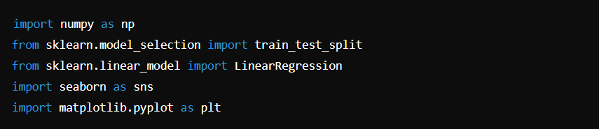

**Explanation:**  
This section imports the necessary libraries:

* numpy for numerical operations.
* train_test_split from sklearn for splitting the dataset.
* LinearRegression from sklearn for building the linear regression model.
* seaborn for loading and visualizing datasets.
* matplotlib.pyplot for plotting graphs.

**2. Loading the Dataset**

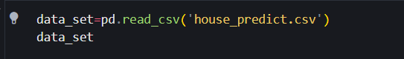

**Explanation:**  
To load a dataset using pandas, you can use the pd.read_csv() function. This function reads a CSV (Comma-Separated Values) file and creates a DataFrame, which is a 2-dimensional labeled data structure with columns of potentially different types.

**Output:**

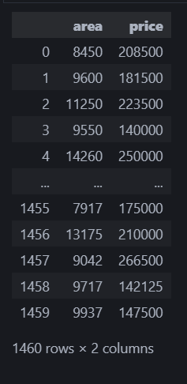

**4. Selecting Relevant Columns**

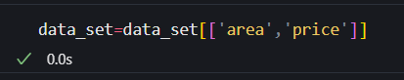

**Explanation:**  
This filters the dataset to include only the columns "area" and "price" which are the features used for this analysis.

**5. Defining Features and Target Variables**

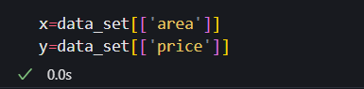

**Explanation:**  
Here, x represents the feature variable (area), and y represents the target variable (price).

**Output:**

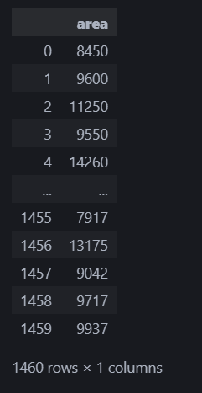

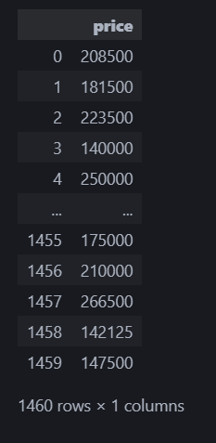

**6. Plotting the Data Points**

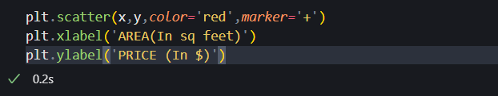

**Explanation:**  
This section creates a scatter plot to visualize the relationship between area and price. plt.scatter() generates the plot, while plt.xlabel() and plt.ylabel() label the axes.

**Output:**

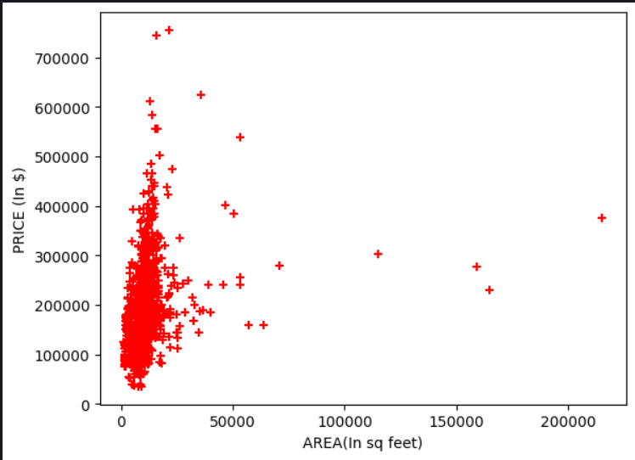

**7. Splitting the Dataset**

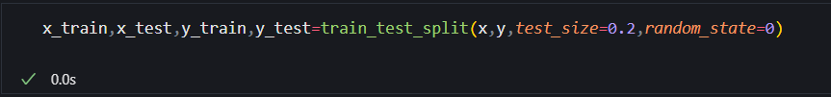

**Explanation:**  
The dataset is split into training and test sets. 80% of the data is used for training, and 20% is used for testing

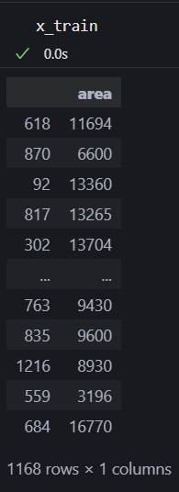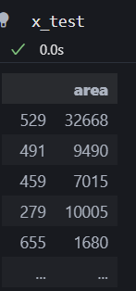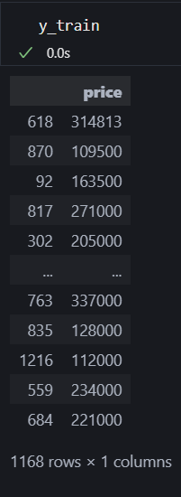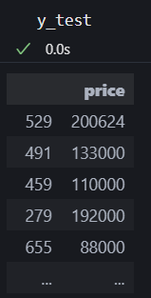**8. Reshaping Data**

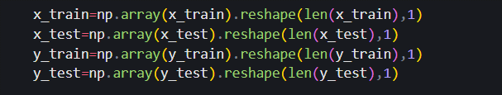

**Explanation:**  
The data is reshaped to ensure it meets the input requirements for the linear regression model.

**9. Creating and Training the Linear Regression Model**

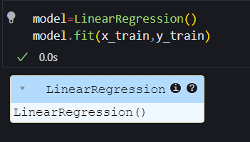

**10. Extracting Model Parameters**

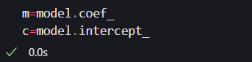

**Explanation:**  
The model coefficients (slope) and intercept are extracted from the trained model.

**11. Making Predictions**

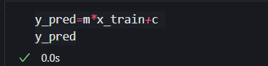 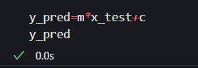

**Explanation:**  
Predicted values for the training and testing are calculated using the linear model.

**12. Plotting Predictions(Training set)**

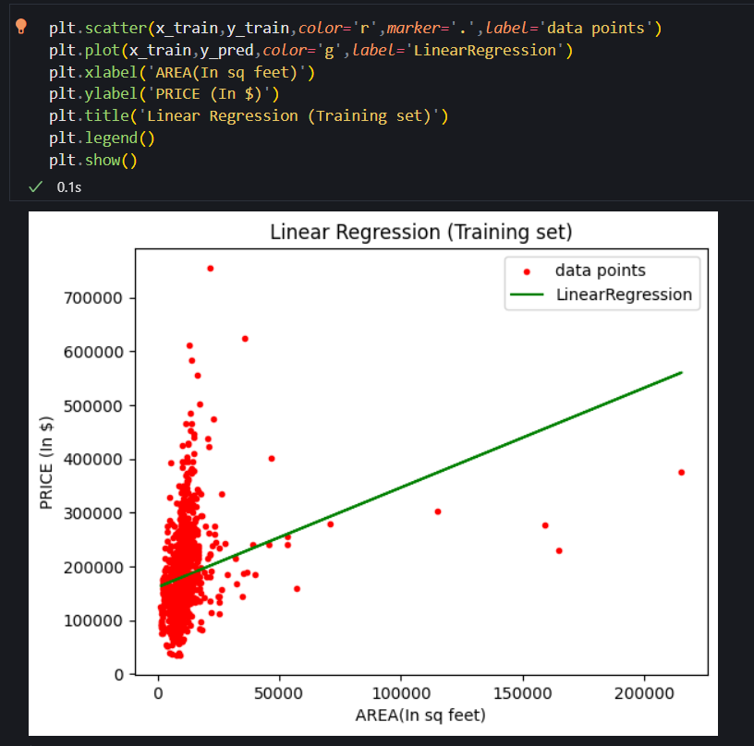

**Explanation:**  
Finally, a scatter plot of the training data is created along with a regression line to visualize the linear relationship.

**13. Plotting Predictions(Testing set)**

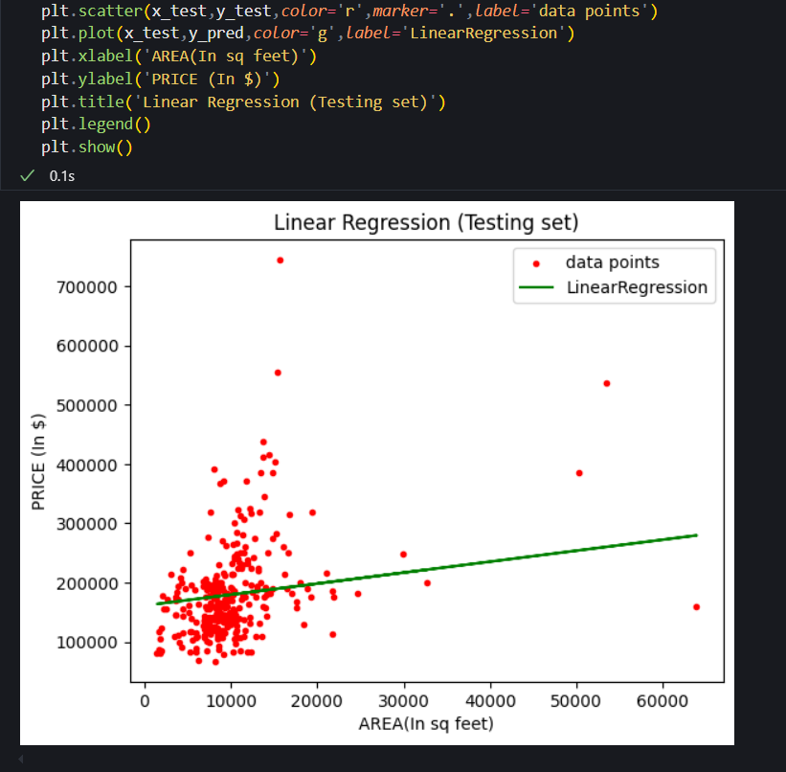

**Explanation:**  
Finally, a scatter plot of the testing data is created along with a regression line to visualize the linear relationship.

***